NiftyReg Error:  
  
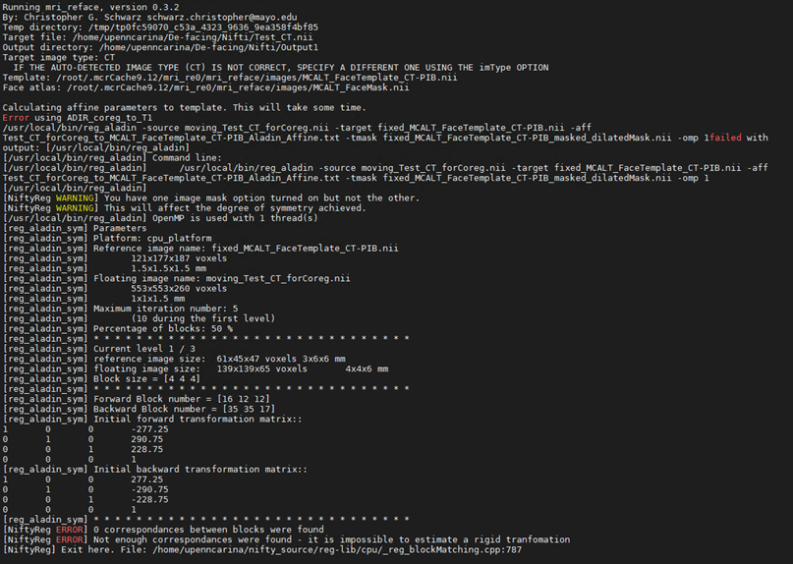  
  
  
Left: Original nii Images; Middle: Defaced nii images; Right: Defaced PNG   
  
Case 1:

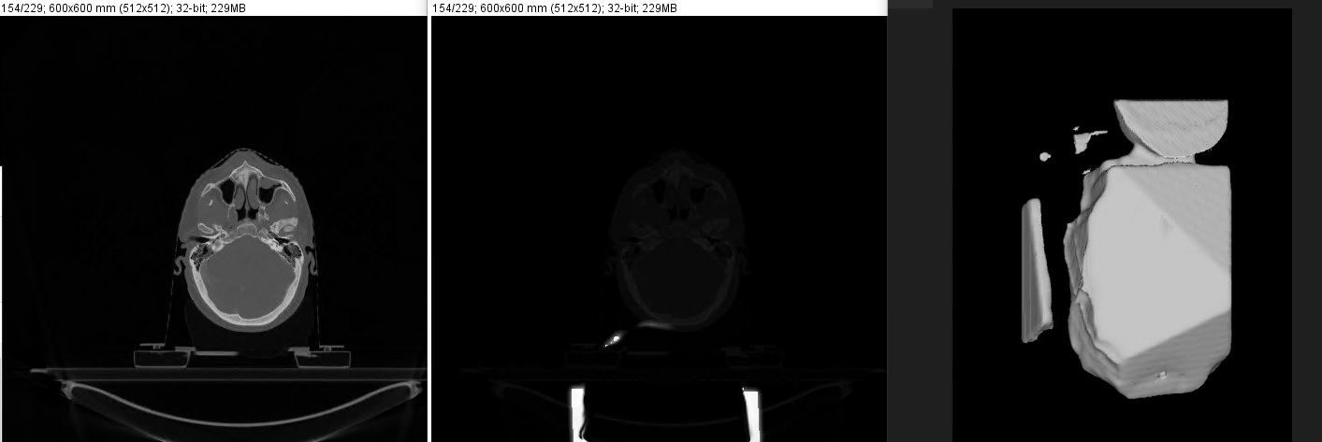

Case2:

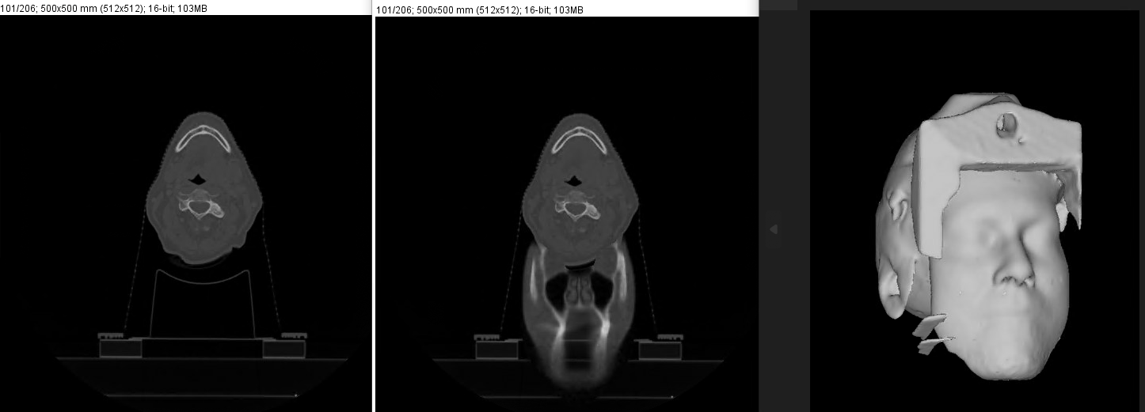

Case3:

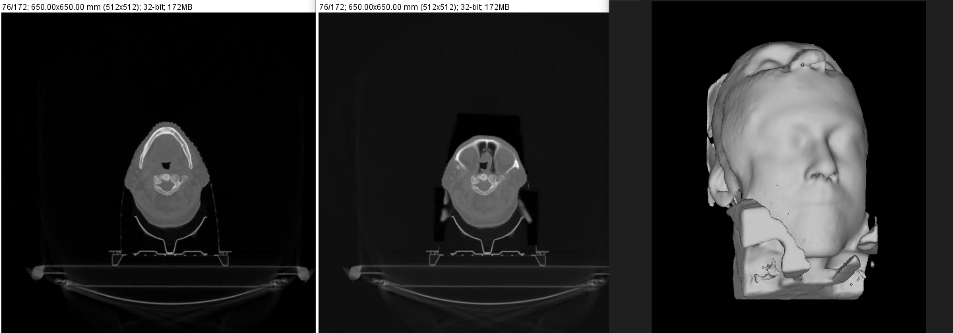

Case 4:

